SELECT INITCAP(ENAME) FROM EMP;
INITCAP(ENAME)
King

SELECT LENGTH(ENAME) FROM EMP;

SELECT ENAME, LENGTH(ENAME) AS "LENGTH OF WORDS"
FROM EMP
WHERE LENGTH(ENAME) = 4;

SELECT SUBSTR('Albert Einshtein', 0,6) FROM DUAL;

RPAD() LPAD()

SELECT LPAD('Day', 7, '/') FROM DUAL;

// spaces
SELECT LPAD('Day', 7) FROM DUAL;

SELECT RPAD('Day', 7, '&') FROM DUAL;

SELECT LTRIM('yyyyyyyyyyyyyyesss', 'y') FROM DUAL;
-- delete all - left specific characters

SELECT RTRIM('nooooooooooooooo', 'o') FROM DUAL;
-- DELETED ALL - Rigrht specific characters

SELECT ROUND(1.975,2) FROM DUAL;

SELECT FLOOR(1.975) FROM DUAL;

SELECT CEIL(1.975) FROM DUAL

SELECT TRUNC(2.99) FROM DUAL;
SELECT FLOOR(2.99) FROM DUAL;
SELECT CEIL(2.99) FROM DUAL;
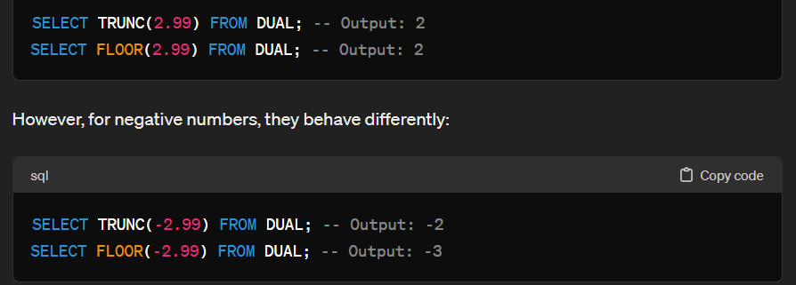
SELECT TRUNC(2.9999, 3) FROM DUAL;

SELECT SYSDATE FROM DUAL;
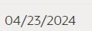

SELECT SYSTIMESTAMP FROM DUAL;
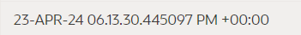

SELECT add_months('04/23/2024', 1) from dual;
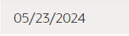

SELECT add_months(sysdate, -4) from dual;

SELECT months_between('12/30/2023', '12/31/2022') FROM DUAL;

SELECT TRUNC(systimestamp, 'month') from dual;
SELECT TRUNC(systimestamp, 'year') from dual;

SELECT hiredate, trunc(hiredate, 'month') from emp;
SELECT hiredate, trunc(hiredate, 'year') from emp;

SELECT ename, hiredate, TRUNC(hiredate, 'year')
from emp
where TRUNC(hiredate, 'year') = '01/01/1982';

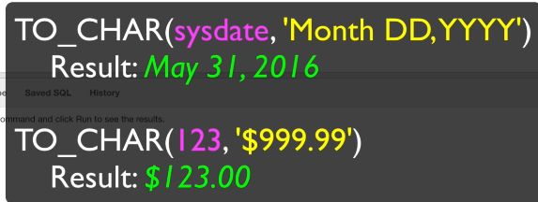
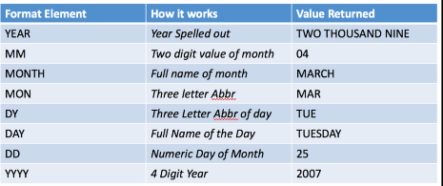

SELECT TO_CHAR(sysdate, 'yyyy') FROM DUAL;

SELECT SYSTIMESTAMP AT TIME ZONE 'GMT' + INTERVAL '4' HOUR AS CURRENT_TIME_GMT_4 FROM DUAL;

SELECT TO_CHAR(SYSTIMESTAMP AT TIME ZONE 'GMT' + INTERVAL '4' HOUR, 'HH24:MI:SS') AS CURRENT_TIME_GMT_4 FROM DUAL;

SELECT TO_CHAR(sysdate,'ddth "of" month, yyyy') FROM DUAL;

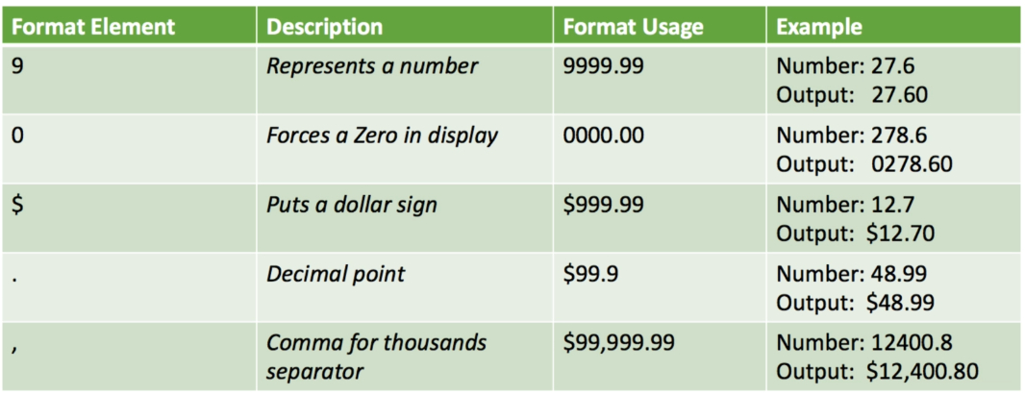

SELECT ename, sal as "org", TO_CHAR(SAL, '$99,999.99') as "formated" FROM EMP;



SELECT TO_DATE('12-31-1933', 'mm/dd/yyyy') "Convert String To Date" FROM DUAL;

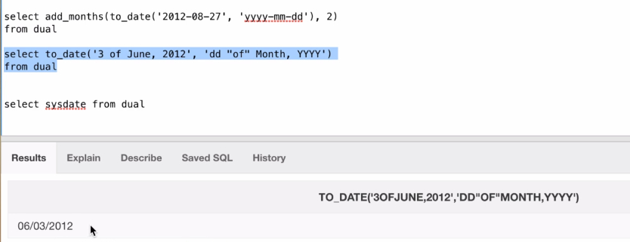

SELECT to_date('7 of july 2020', 'dd "of" Month, YYYY') FROM DUAL;

Some More Date Functions
I'd like to introduce you to 2 more functions. You should practice and memorize these.
LAST_DAY(d)
last_day is a date function that requires a date as an argument. It returns the last day of the month in which the given date falls. The argument is required for this function to work properly.

NEXT_DAY(d, c)
The first argument is the date and the second argument is a text reference to a day of the week. Both arguments are required for this function to work properly. This function returns a valid date representing the first occurrence of the c day following the date represented in d.

SELECT LAST_DAY(SYSDATE) AS "Last_Day_of_Month" FROM DUAL;

SELECT NEXT_DAY(SYSDATE, 'MONDAY') AS Next_Monday FROM DUAL;
SELECT NEXT_DAY(SYSDATE, 'SUNDAY') AS Next_Monday FROM DUAL;

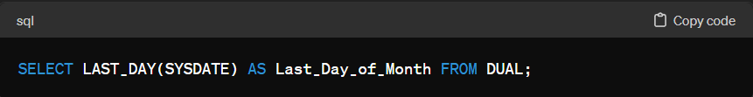
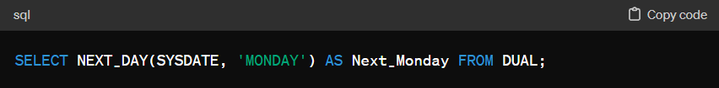

NVL

SELECT ename, sal, NVL(TO_CHAR(comm), 'NO DATA') AS COMMISION
FROM EMP
WHERE empno in (7839, 7698, 7566, 7654);

SELECT ename, length(ename), NVL(TO_CHAR(nullif(length(ename), 5)), 'length is 5') FROM EMP;

SELECT ename, length(ename), nvl(nullif(to_char(length(ename)), to_char(5)), 'length is 5') FROM EMP;

SELECT ename, length(ename),
NVL(TO_CHAR(nullif(length(ename), 5)), 'length is 5') AS "length" , sal
FROM EMP
WHERE sal > 2000;

